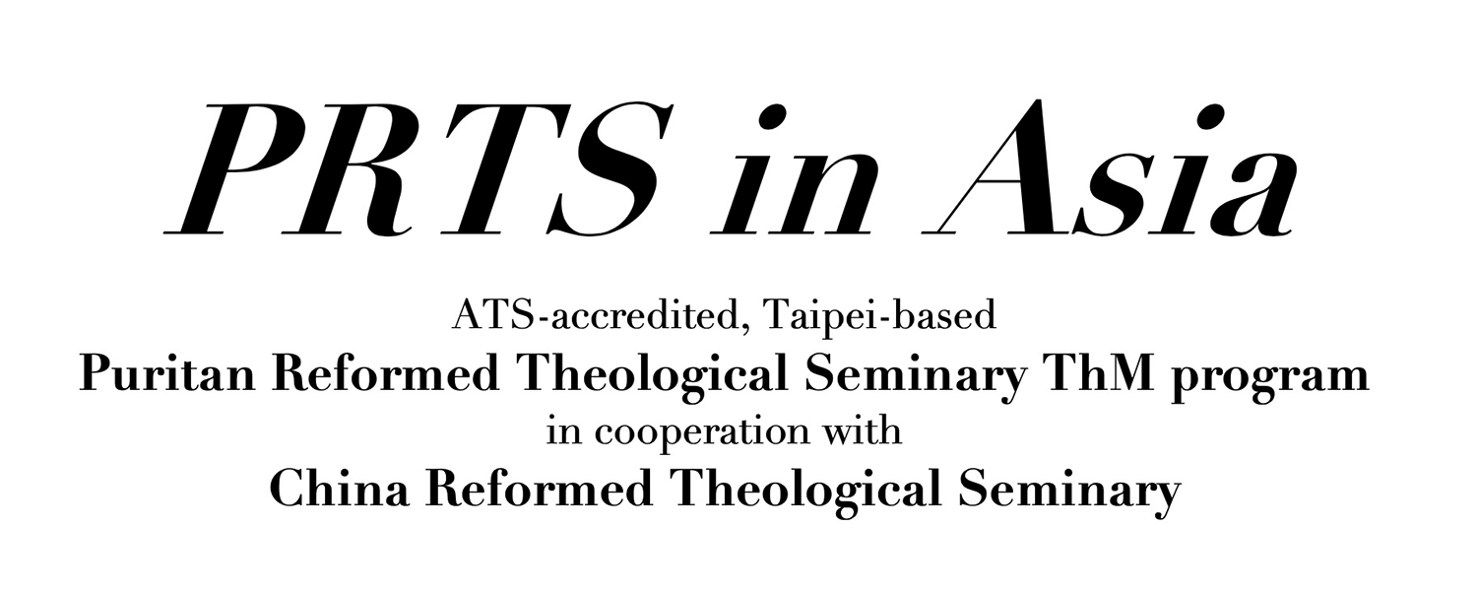

Residency Requirement Form

Applicant Information

Name:
Gender:
Date of Birth:
Marital Status:
Number of Children:
Residence:
Email:
Tel:

- How many ThM courses do you intend to take this year and next year?

- PRTSiA offers intensive modular courses. Each course requires students to spend about four weeks in Taipei. If you were to take three courses throughout the year, you’d be required to spend a total of 3 months in Taipei. Please provide two references from your current employing church or institution to vouch for the availability of your time.

Reference Name:
Job Title:
Email:
Telephone:

Reference Name:
Job Title:
Email:
Telephone:

Please send this form back to:
Irene Lin, PRTS in Asia ThM Admission Coordinator, irene.lin@crtslive.net
https://www.prtsinasia.com

